

Comsats University Islamabad Abbottabad Campus

INTRODUCTION

Group Members:

* Basit Iqbal (Fa21-bse-050)

Project Name:

* Genetic Algorithm

Course Name:

* Software Testing

Submitted to:

* Mukhtair Zamin

University:

* Comsats University Islamabad Abbottabad Campus

Submission Date:

* 09th May 2024

Assignment Number:

* Assignment 01

**Assignment No: 01**

**Question:**

What is the Test Plan. Explain the Test Plan Templates Evolution?

**Answer:**

**Test Plan**:  
Test Plan is a formal document that act as a blueprint for the complete testing process, and it also ensures the quality and reliability of the Software.

**Importance:**

Test Plan is considered an important element because it guides the tester to perform testing in the most efficient way and maintain the log of the testing process. Also, it outlines the approach or strategy that would be used to test the Software and also to ensure the coverage of all the requirements and systematic evaluation of the software quality, ultimately decreasing the chances of risks and defects. And at last, empowering the reliability of the Software Product.

**Evolutions:**

|  |  |
| --- | --- |
| Years | Templates |
| 1983 to 2002 | IEEE 829 Standard Template |
| 2002 onward | ISTQB Template |
| Mid 2000’s | Agile Test Plan Template |
| After 2010 | Customized Templates |
| Ongoing / Today | Modern Templates |

1. **IEEE 829 Standard Test Plan Template:**

**Date:** 1983

**Overview:**

It Provided a structured format for “Test Documentation”.

**Purpose of Development:**

**Issue:**

When the IEEE 829 standard was not developed, there was a lack of standardized documentation practices in Software Testing. Test Plans varied widely in format, content, and level of detail, which lead to inconsistencies and inefficiencies.

**Solution:**

IEEE 829 provided a structured and standardized format for documenting test plans, ensuring consistency across different projects and organizations. This standardized approach improved communication and traceability in testing activities.

**Template:**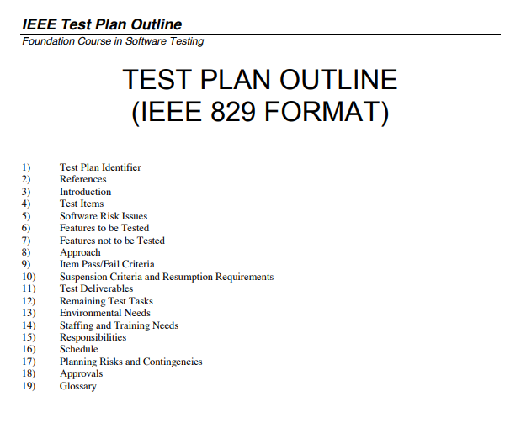

🡨------------------------------------------------------🡪

1. **ISTQB Test Plan Template:**

**Date:** 2002

**Overview:**

The “International Software Testing Qualifications Board” (ISTQB) introduced a test plan template as a part of its certification syllabus.

**Purpose of Development:**

**Issue:**

Testing terminology and practices differed across regions and organizations, leading to confusion and miscommunication among testing professionals.

**Solution:**

The ISTQB test plan template established a common vocabulary and framework for test planning. It ensured a global understanding of Testing concepts and best practices, enhancing collaboration and knowledge sharing in the testing community.

**Template:**  
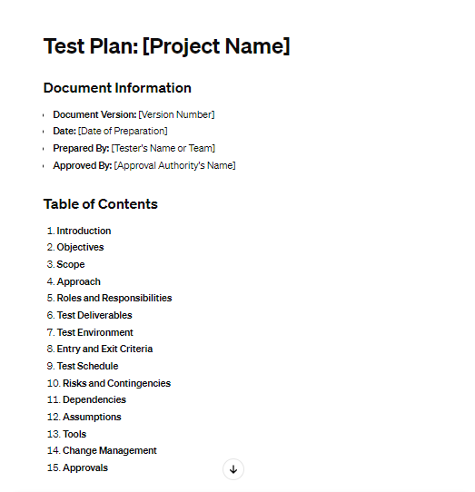

1. **Agile Test Plan Template:**

**Date:** Mid 2000’s

**Overview:**

As in Mid 2000’s agile methodologies got popular so the testing also evolved to be more lightweight and iterative.

**Purpose of Development:**

**Issue:**

Traditional Test Plans were heavily documented for Agile Development environments, where the requirements and priorities change frequently. Also, Agile development opposes heavy documentation and promotes less documentation approach.

**Solution:**

Agile test plan templates are lightweight, adaptable, and focused on essential testing activities. They align with Agile principles of flexibility and responsiveness to change, enabling testing to keep pace with rapid development iterations.

**Templates:**

There are various templates of Agile Test Plan:

1. One-Page Agile Test Plan.
2. Test Strategy in Agile.
3. User Story-Based Test Plan.
4. Agile Test Pyramid.
5. Exploratory Test Planning.
6. Continuous Testing Plan. Etc

And I have gathered some templates and pasted below.

1. One Page Agile Test Plan:

1. Agile Test Plan Strategy:

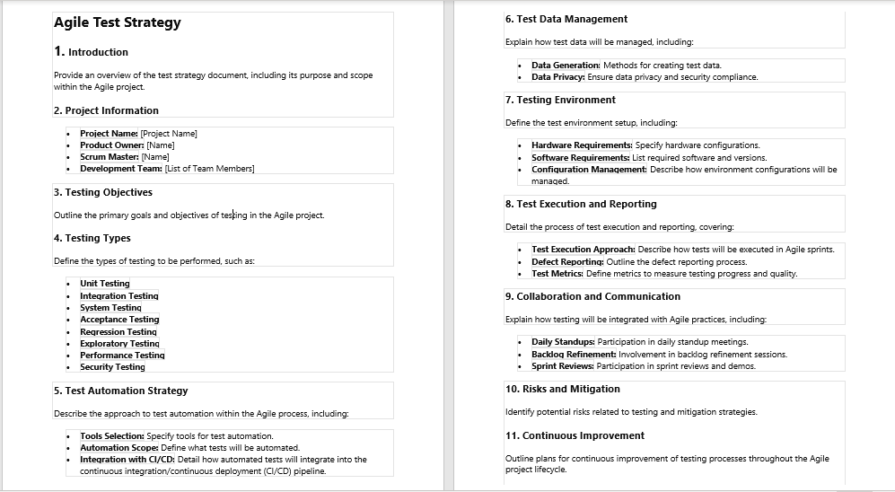

1. User-Story Based Test Plan:

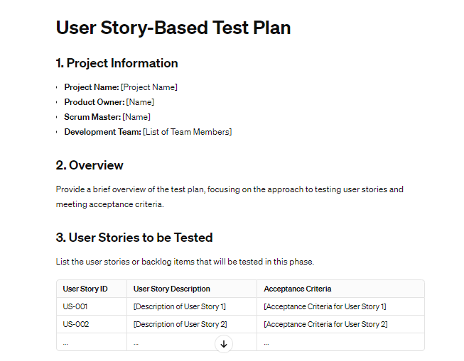

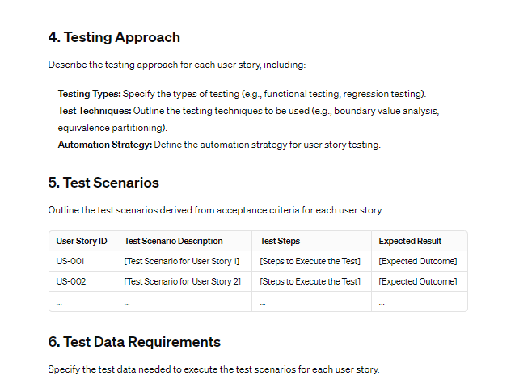

1. **Customized Organizational Templates:**

**Date:** Ongoing

**Overview:**

Almost all the organizations develop their own test plan templates tailored to their specific needs and processes.

**Purpose of Development:**

**Issue:**

Generic test plan templates might not be able to address the unique requirements, processes, and constraints of individual organizations or projects.

**Solution:**

Customized organizational templates allow companies to tailor test plans to their specific needs, in corporation industry standards, compliances requirements, and internal best practices. This customization improves efficiency and effectiveness in testing activities.

**FAANG companies:** Almost all the FAANG companies are known for their emphasis on automation. Their test plans likely incorporate a high degree of automated testing throughout the development lifecycle.

All the FAANG companies including Microsoft, Google, and Amazon have their own custom Test Plan Template, so that they can tackle the problem in their own specific ways.

None of the templates of the FAANG companies are available because they are obviously not available publicly.

1. **Modern and DevOps-oriented Test Plans:**

**Date:** 2010s

**Overview:**

After the rise of DevOps and continuous testing, test plans have become more integrated into automated pipelines.

**Purpose of Development:**

**Issue:**

Traditional test plans were not designed to support continuous integration and continuous delivery (CI/CD) practices, leading to bottlenecks and delays in testing.

**Solution:**Modern test plans for DevOps emphasize automation, scalability, and integration with CI/CD pipelines. They facilitate continuous testing throughout the software development lifecycle, ensuring rapid feedback and quality assurance in fast-paced delivery environments.

1. **Industry Trends:**

**Shifted towards Automation:**

More shifted toward automation testing within test plans to increase the efficiency and test coverage.

**Integration with CI/CD Pipelines:**

Test plans are integrated into continuous integration and delivery pipelines to support rapid and reliable software releases.

**Focus on Traceability and Reporting:**

Test plans include provisions for traceability matrices and detailed reporting to ensure transparency and accountability in testing activities.

**Summary:**

As I have explained the evolution in detail, now I would like to summarize the whole discussion.  
The evolution of test plans in software testing has progressed from early documentation standards to current focus on agility, automation , and integration with modern dev practices, Initially introduce with the IEEE 829 standard in the 1980s to address the lack of standardized docs, test plans have since evolve to include standardized templates such as mentioned in the ISTQB. With the introduction of Agile methodologies, test plans adapted to become more lightweight and flexible, focusing on iterative development and delivery. Customization became important as organizations tailored test plans to meet their specific needs, incorporating industry regulations tailored test plans to meet their specific needs, incorporating industry regulations tailored regulations and internal processes. In recent years, the integration of test plans with DevOps practices and continuous testing has become prominent, emphasizing automation, scalability, and rapid feedback. The evolution of test plans has not stopped and never will as change is inevitable and so the test plan will keep on evolving with the industry practices.

**Conclusion:**

Hence from all the above discussion, we can conclude the Test Plan templates were developed to keep everyone on same page and were done manually but today in the era of AI. They are mostly automated.

🡨---------------------------------------------------------------------🡪 The End…………!